Technical Report #001 CovidSIMVL

August 28, 2020

Ernie Chang, MD PhD

Victoria, BC

**INITIAL RELATIONSHIP BETWEEN POPULATION DENSITY, MINGLE FACTOR AND SIZE**

All the trials were run with size=12

The variables were population (100, 50 and 25) and mingle factor (4,3,2) applied to all agents

Initial CaseFile-csv is for one agent (#10) with infective viral load and time since infection of 4 days

Each setting was run 10x and averaged.

Each run was stopped after the first 10 new infections were reached.

The duration in hours was then recorded.

The graphs were then charted for averages of

NEW INFECTIONS PER HOUR

ODDS of one infection in a single hour

ODDS of the infection being ME (or any specific person)

against the parameter settings of

100 agents mingle-factor 4

100 3

100 2

50 4

50 3

50 2

25 4

DISCUSSION

The larger the population, the more infections/hour.

The larger the mingle factor, the more infections/hour.

The average infections per hour = observed new infections/total duration to reach target infections

If there were 10 infections in 100 hours, the average inf/hr = 10/100 = 0.1

The odds of there being any infection in that hour is the reciprocal ie 1/0.1 = 10

So odds of having any infection in one hour is 1 in 10.

The odds of a specific person being infected varies with N, the population of agents, and would

be N x odds of any infection. So if N was 50, the odds of ME being infected would be 50x10 = 1 in 500.

Data for P=100 with mingle factor = 4, 3, 2



Data for P=50 with mingle factor=4,3,2



Data for P=25 with mingle factor=4



CORRESPONDING GRAPHS

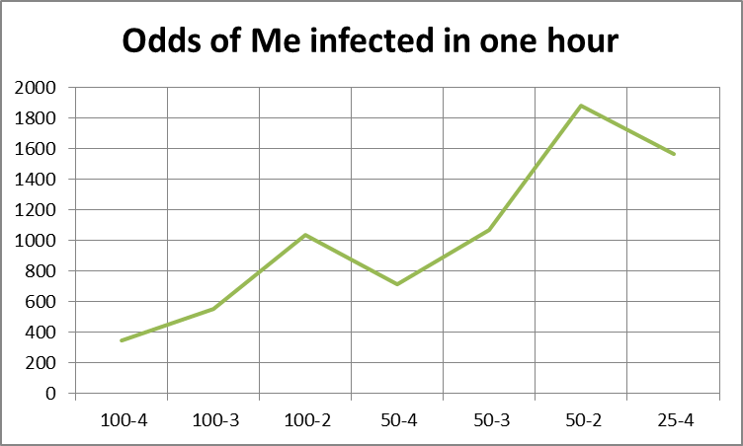

DISCUSSION

The methodology provides a quantitative generation of the odds of infection in various parameter settings, and we can of course see if the next 10 infections take the same duration as the first 10, though it should be intuitively clear that the last 10 may take longer, as the remaining susceptibles may be spaced further away from the active infectives.

With this modeling capacity, the question arises as to what the acceptable level of infection might be. Having the ability to vary parameters settings, and observing the quantitative changes in risk, permits firmer guides to actual interventions rather than relying on intuitive ad hoc approaches.